Delete in Binary Search Tree.
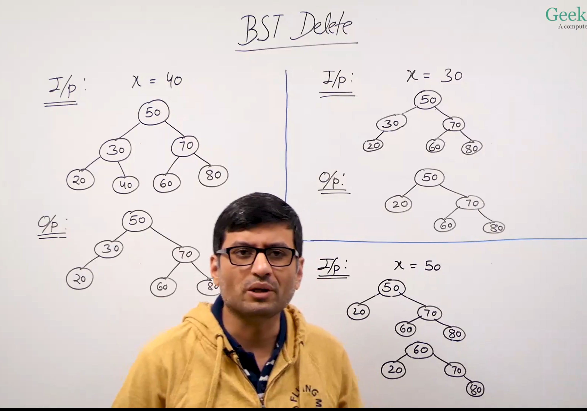
BST deletion: exactly 3 cases
There are exactly 3 cases for BST deletion. Some implementations split case 2 into two subcases, but they’re handled the same way.
The 3 main cases
CASE 1: Node with NO children (Leaf Node)
- No left-child, no right child
- Solution: Delete the node (set parent's pointer to null)
CASE 2: Node with ONE child
- Has either left child OR right child (but not both)
- Solution: Replace the node with its only child
- Note: Some implementations split this into:
- Case 2a: Only left child exists
- Case 2b: Only right child exists
- But both are handled the same way (just different direction)
CASE 3: Node with TWO children
- Has both left child AND right child
- Solution: Find in-order successor (or predecessor) and replace

Alternative view: 4 cases (if splitting case 2)
If you want to be more specific, you can break it down to 4 cases:
- No children (leaf node)
- Only left-child exists
- Only right-child exists
- Both children exist
But cases 2 and 3 are handled identically (just replace with the single child), so most textbooks and implementations group them as one case.

Edge cases to consider
These are not separate deletion cases, but important checks:
- Empty tree: Check if root is null before deletion
- Node not found: The key doesn't exist in the tree
- Deleting root node: Still falls into one of the 3 cases based on how many children the root has

Summary
- Standard view: 3 cases
- Detailed view: 4 cases (if you split the one-child case)
- All implementations handle the same 3 logical scenarios
The three-case model is standard and sufficient for BST deletion.


